Sample Title of Abstract for ATWIRES Workshop in Kraków

X. Author¹, Y. Firstcoauthor¹, Z. Secondcoauthor¹, W. Presenting-Author²

¹ Authors’ Affiliation, First Institution, Address, Street, City, Country
² Optionally, if different, put here another affiliation e.g. Presenting-Author Affiliation,
Second Very Important Institution Name, Address, Street, City, Country
(optionally) email: presenting-author@SVIinstitution.edu

The main text of the abstract. The text should be justified left and right. Indent first lines of paragraphs. Put numbers of the references (not more than 5) between square brackets [1,2]. Please remember, that the total length of the abstract (including title, authors, affiliations, references, pictures) should not exceed one A4 page (margins 2.5cm). This is the end of the first paragraph.
Use a new line for references [3]. Each one should contain: reference number in square brackets, author(s) with initials, journal name, volume number, year in parentheses, followed by the number of the first page [4]. End of the second abstract paragraph.
Below the abstract body put a blank line and in the new line specify again the following information: consecutive abstract number (if more than one is submitted), preferred format of the presentation (word: oral or poster). End of the third paragraph.
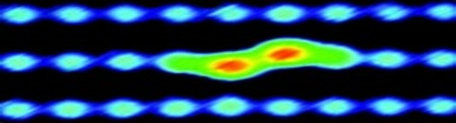Fig. 1: The example of the optional Atwires figure. For figure caption use 10 pts character set [5].

Optional acknowledgement. This work was partially supported by EC projects ATMOL and PAMS.

[1] A. Author, B. Author, C. Author., Journal Name of the First Optional Reference, 3 (2014) 1234.
[2] D. Author et al., Jour. Appl. Atwires Sci., 2 (2014) 321.
[3] E. Author, F. Author, G. Author, H. Author, I Author, J. Author, K. Author, Int. J. Atwires Sci. Technol., 1 (2014), 111.
[4] L. Author et al, International Journal of Atwires Projects, 4 (2014) 123.
[5] M. Author, N. Author, O. Author, Atwires, 2 (2014) 234.

1, oral

